Log file

Thursday, June 25, 2009:
- v1 ER-diagram (rough)

Saturday, June 27, 2009:
- v1 ER-diagram (refinements + neat copy)
- SQL statements

Tuesday, June 30, 2009:
- v2 ER-diagram

Thursday, July 2, 2009:
- v3 ER-diagram
- v4 ER-diagram

Friday, July 3, 2009:
- v5 ER-diagram

Sunday, July 12, 2009:
- SQL statements for v5 (rough)

Monday, July 13, 2009:
- SQL statements refined
- Learned basics of Oracle
- Learned basics of Forms
- Learned basics of Triggers
- Created dummy data to populate tables with

Tuesday, July 14, 2009:
- Created more dummy data
- Made refinements to relational schema and database
- Created Database
- Created Forms
- Created Triggers
- Learned basics of Reports

Wednesday, July 15 + Thursday July 16, 2009:
- Minor refinements + improvements
- Completed Triggers
- Completed Forms
- Completed Reports
Forms

- AccountOwners

This form is used for access to the information of the account owners. This form can be used for searching, authenticating, modifying, or creating accounts. The form is split into different tabs for display of different account information.

Account Information
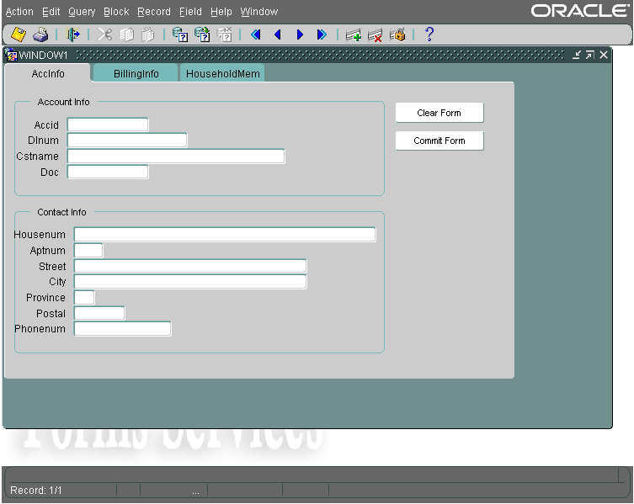
This tab is used to display the basic account information as well as the contact information for the account owner. Queries can be performed using the search buttons on the top tool bar. The two buttons on the side are used for account management. The Clear Form button will clear the form of any information currently being displayed. The Commit Form button will commit any changes to existing records, as well as commit the creation of new records.

Billing Info
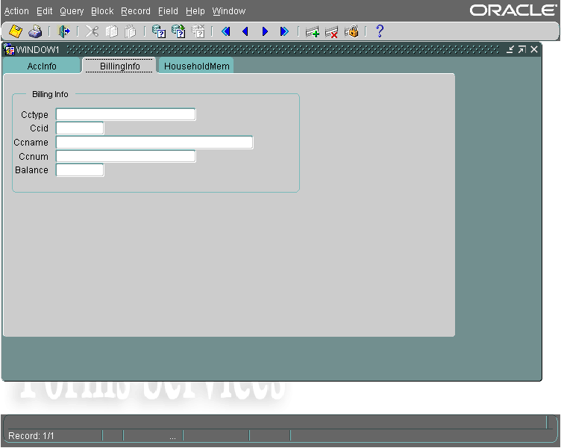
This tab is used to display, insert, and modify credit card information as well as the account owner’s current balance.

Household Members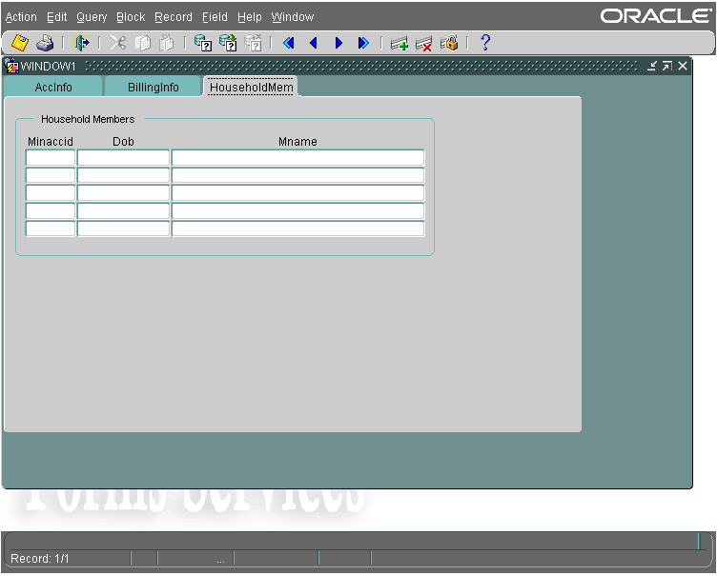
This tab is used to display, insert, and modify household members which can rent under the primary account owner.

- Employees

This form is used for access to the information of the employees. This form can be used for searching, authenticating, modifying, or creating employee accounts.
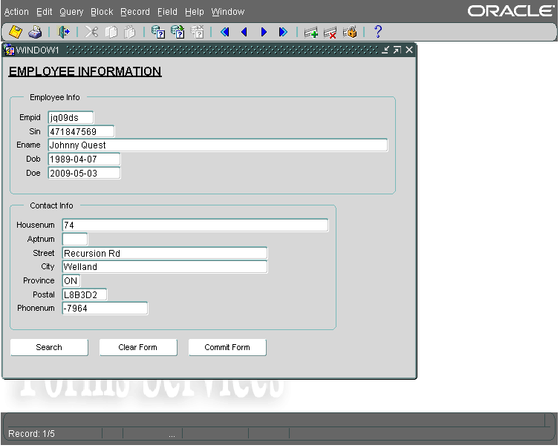
This form will display the Employee information as well as the Contact information for the chosen employee. The buttons along the bottom can be used for administrative purposes. The Search button can be used to query a specific employee. The Clear Form button will remove any data currently displayed on the form. The Commit Form button will commit any changes to existing records as well as commit the creation of any new Employee records.

- Transaction

The Transaction forms are where the majority of use will happen. The form can be used for the creation of transaction, as well as the addition of movie rentals, previously viewed purchases, and new movie purchases to the transaction.

Transactions
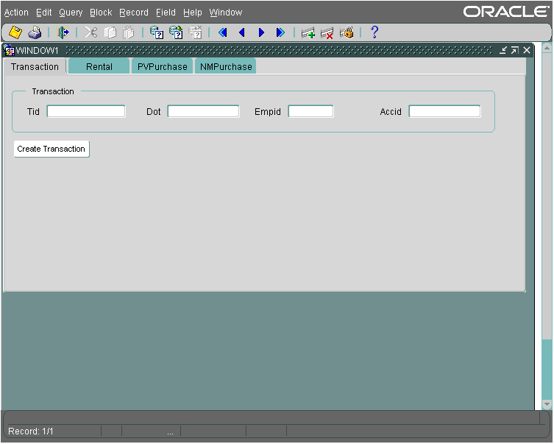
The transactions will be created in this tab of the form. The TID (Transaction ID), DOT (Date of Transaction), and EmpID (Employee ID) are required fields for the creation of a transaction, as AccID (Account ID) is not required if the transaction is for a movie purchase not a rental. The Create Transaction button on the button will commit the transaction into existence.

Rental
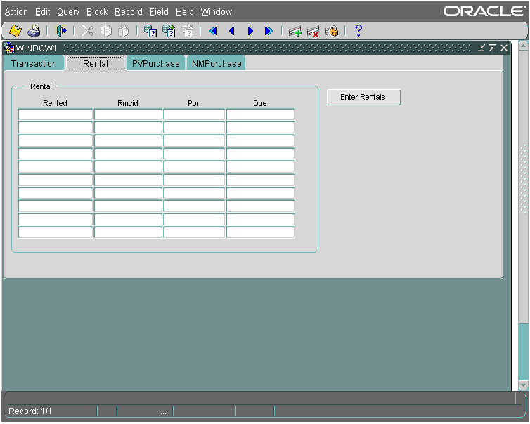
This form is used the addition of Movie Rentals to the transaction. The Rented column is filled with the Tranaction ID (TID), and the RMCID is the Rental Movie Copy ID, which is taken from the rented movie. When the Enter Rentals button is pressed, the rentals are committed to creation, and the POR (Price of Rental) and the Due date are automatically retrieved and displayed in the form.

Previously Viewed Purchase
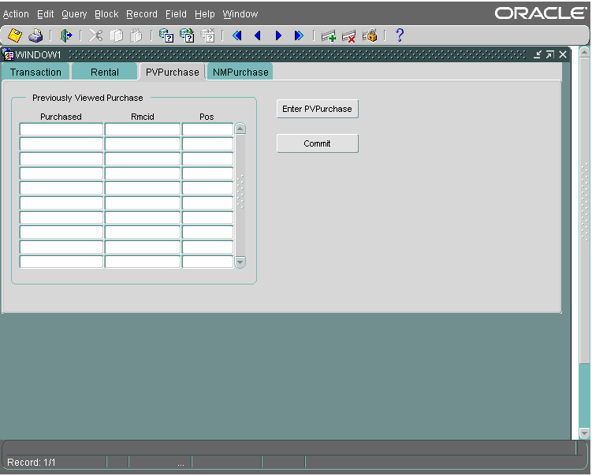
Movies which had been for rent but are now available for purchase are considered Previously Viewed movies. These can be added to the transaction here in the PVPurchase tab of the form. The Purchased column is entered with the Transaction ID, and the RMCID of the movie is entered. When the Enter PVPurchase button is pressed, the PVPurchase record is added to the transaction.

New Movie Purchase
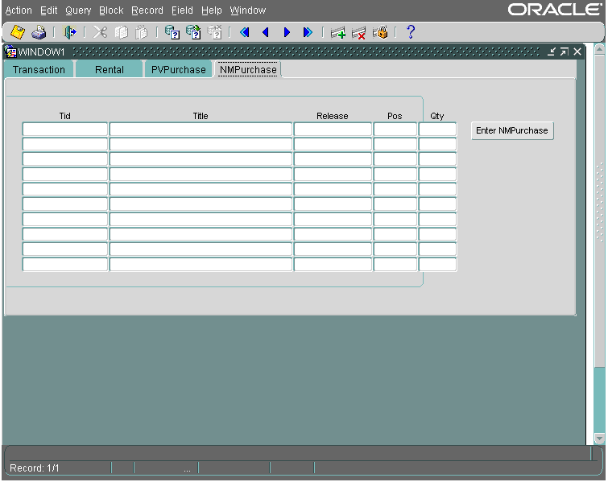
New movie purchases are added to the transaction here. The Transaction ID, Title, Release date, and quantity of the movie being purchased is entered into the form, and is added to the transaction.

- Rental Return
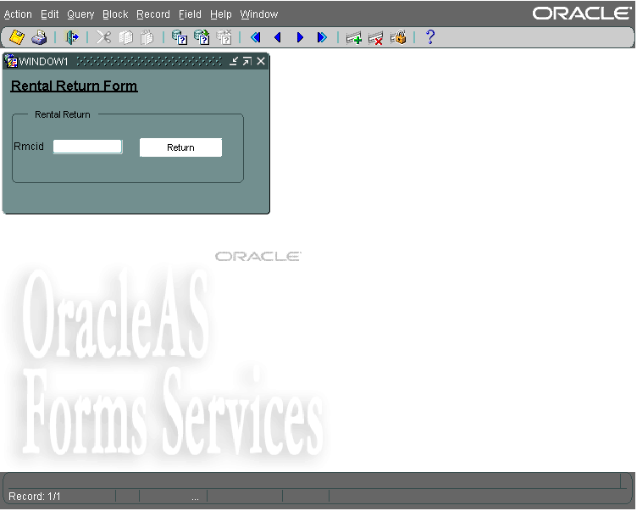
The returns of the rentals are handled by this form. The RMCID is entered into the form, and the Return button is pressed, returning the RMCopy to a rentable state.

- Movie Searching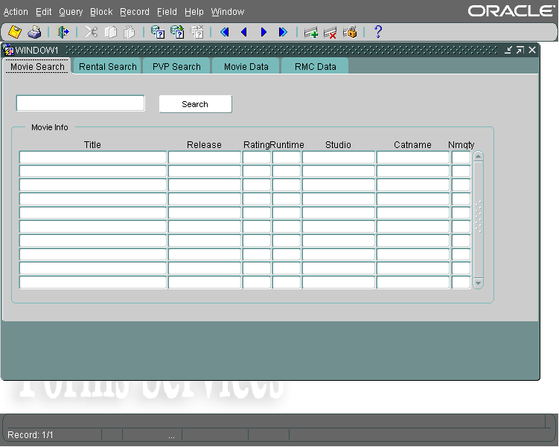

The movie searching form us used for searching for specific information based on movie title, or part of a movie title. The text is entered into the top search bar, and then the search button is pressed. This will bring up different information based on which search tab is selected. The Movie Search tab will bring up information on if the movie is in the movie database, as well as the amount of new copies for sale of each.
The Rental Search tab will do a search based on the movie entered if the movie is available for rental.
The PVP search tab will do a search based on the movie entered if the movie is available for purchase and is previously viewed.

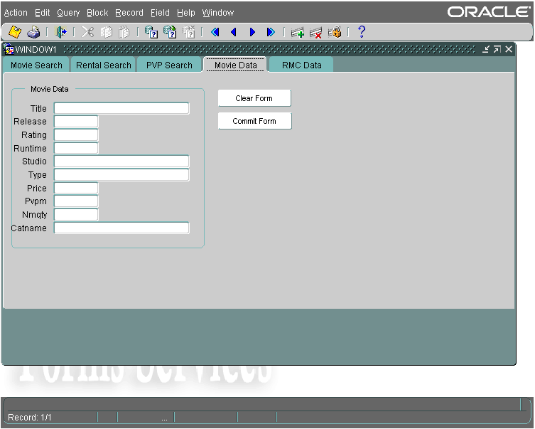
The Movie Data tab is used for the entry and modification of Movie Info records. A movie can be queried and modified, as well as a new movie record can be created.
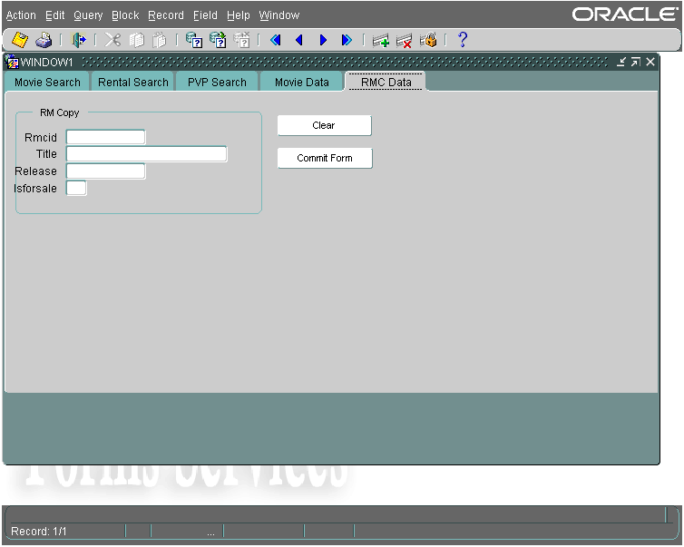
The RMC Data tab (Rental Movie Data) is used for adding copies of a movie to rental. The RMCID, Title, and Release are entered into the RMCopies records, as well as the ability to choose if the RMCopy is for sale or not.

Reports

1. “A report on all late movies, which accounts have rented them, and the number of days that they are late, sorted by the number of days which they are overdue.”

Return late movies in descending order of amount of days late and also return account ID.
Uses tables: RMCopies, Transaction and Rental.
Once the cross product is done with all the tables, there is a condition to select tuples where ‘date of return’ (DOR) is null, that is, has not been set yet, thus the rental hasn’t been returned as yet. Then there a join is performed on the transaction ID (so that we can get the customer account ID), and another join on the movie copy ID (so that we can get the movie title). Then a safety check is performed to make sure that the movie is a rentable movie and not a previously viewed purchasable movie. Then only movies that are late are selected (condition to check that the due date is less than the current date, thus the due date has passed already).
The tuples are ordered by due date ascending, thus the oldest due date will be at the top.
The following fields are listed: the account ID, the movie title, and a “days late” column that subtracts the due date from the current date and then truncates the results for whole days.

2a. “A report which will identify the most popular movie titles over a dynamically assigned time period, set by the person running the report.”

Over a user set time period, return most popular movies (i.e. movies from rented + pv purchase + nm purchase, that have the most transactions associated with them).

For every category (i.e. rented, pv-purchase, nm-purchase) return the title, transaction id, and count for every movie that was in a transaction between (which is inclusive) the dates specified by the user. Grouping and unions are used to do this.
All of that is nested into the From clause of another query. This query sums the count for the movies in different types of transactions with the use of an aggregate function and by grouping and sorting the count column in descending order.
Then that is nested into the From clause of another query. This query selects the top 5 with use of rownum (which requires the inner query to have an Order By clause).

2b. This is a modified version that will return the most popular movie titles of all time (i.e. time from the first transaction till the current time). We decided to include this version because it seems like a fun statistic that would be nice to have.

This version is almost the same as 2a, except that this version doesn’t use the Transaction table at all, because it doesn’t need to make use of the date of transaction.

3. “A report that, given a specific account (entered by the user), will list all their rentals and purchases (must indicate new or previously viewed purchase).”
Return all transactioned movies (must specify between rental, nm-movie and pv-movie) for a given user account.

For every transaction type (i.e. rental, nm-movie purchase, pv-movie purchase) join the transaction ID and select tuples where the account ID matches the specified account ID and do a union on all tables, but for every table there is an extra column for the transaction type and we set every row in the table with the transaction type. This makes it possible to specify what type of transaction it was.
Labour
- Database schema (ER-diagram, conceptual design, SQL statements, etc.) (done by everyone)

- Created realistic dummy data to populate table (and be able to test our work) (done by Dennis)

- Developed and implemented many triggers to maintain database integrity and automate values (that otherwise would have to be entered manually) (done by Tristan)

- Developed and implemented many forms to enter, maintain and search for data throughout the data via a top-notch GUI (done by Kelly)

- Developed and implemented reports on specific queries to gather key information from the database and display in a neat and user-friendly format (done by Dennis)
- Everyone helped each other out with small problems and there was superb teamwork involved in this project. The labour and tasks were evenly divided and shared across all and many hours were put into this project.

